**INTERIM REPORT**

**NATHAN HOR YEW JUN**

**BSc GAME DEVELOPMENT & MULTIMEDIA**

**CANDIDATE NO:263152**

Table of Contents

**Introduction3**

**Objective and Problems3**

Coding4

Visual4

Story5

Gameplay Mechanics5

**Professional and Ethical Considerations6**

BSC Code of Conduct6

**Requirements Analysis8**

**Project Planning9**

Gantt Chart10

Current state10

**References12**

Referenced games12

Reference list12

**Appendices13**

Aim13

Primary Objective13

Extension Objective13

Resource required13

Bibliography14

Study timetable14

Interim log14

**Introduction**

According to a source [2], a game can be defined as a form of participatory, or interactive, entertainment. Gaming has been used to benefit people, such as motivating people to do certain activities, including exercising or complete chores[1]. There are many types of game in this modern era, ranging from massively multiplayer online games to story-driven single player games. For this project, the focus will be on a 3D Horror game heavily inspired by a Korean webtoon, called ‘Sweet Home’

The game is being produced in the Unity Game Engine. The version of Unity that is being used is 2023.1.15f1 . This is because this is the latest version of Unity that provides support for most features that is needed in production of this project.

**Objective and problems**

The goal of this project is to produce a 3D horror game that is fully robust with specific game mechanics which can allow the player to fully immerse into the gameplay and game mechanics of the game.This project will also test the skills of a beginner Game Developer transitioning to an advanced Game Developer. The goal is further push a Game Developers’ ability to create advanced game mechanics which can further alleviate the gameplay of a game. This project will explore the fundamentals of creating a horror game, experimenting on the many aspects of what makes a set piece in a game scary and eerie for the player. The platform this game will be available on is on PC, possibly can be downloaded.

Issues that will arise in the development of this project can be categorized into many different aspects.

1. Coding

There will be difficulty in the programming aspect in the development of this project. To create a free flow combat gameplay between players and enemies will be a big leap in the coding process of this game. Free flow combat can be defined when the player can automatically lock onto the enemy while attacking, which closes the distance between the player and the enemy according to a source[10]. The attacking animation will be timed perfectly to be in sync with the movement. Players can counter enemies AIs individually or in groups which locks both the player and the enemy in a 2-step animation.

To achieve this will require me doing research on games that have been successful in creating a free flow combat gameplay, such as the Batman Arkham series, Sleeping Dogs, Mad Max and the more recent ones, Marvel’s Spider-Man 2. Player movement and collision with its environment will have to be coded accordingly to avoid bugs and provide a smooth gameplay experience for the players. Algorithms will be coded into the game as well to develop a fully functioning save points and to increase the code efficiency. Research will also be done on reducing lag in the game by writing efficient code to improve the player experience. The levels in this game will be procedurally generated to create a more personal experience for each player, as every player will play a different sequence of levels.

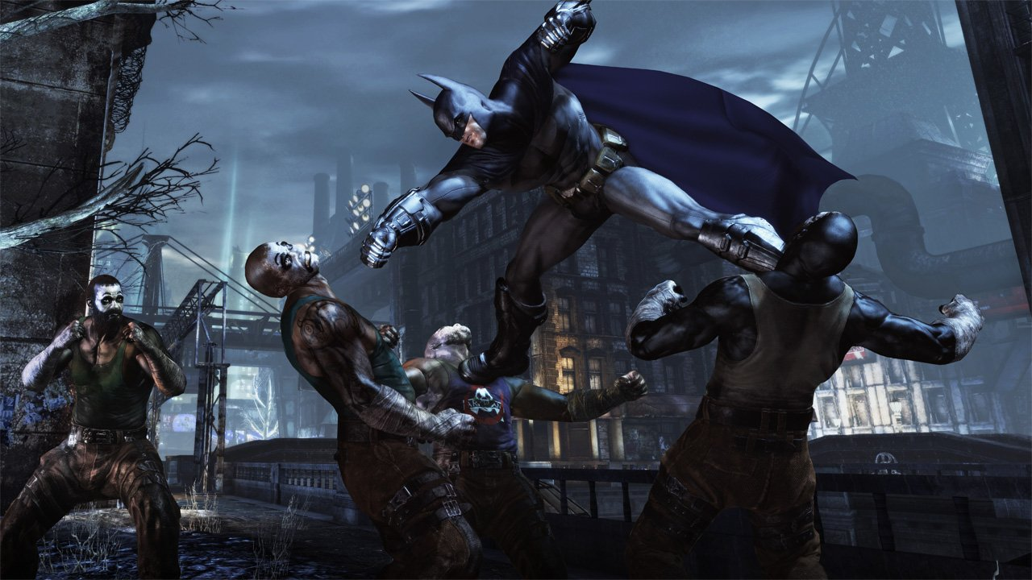

Figure 2. Batman Arkham City

1. Visual

The visual aspects are essential to the success of this project. The problem arises with creating the optimal level design that sells the horror aspect of the game. Suitable lighting to create an eerie atmosphere and dark and gloomy texture on most objects and buildings in the game to give the player the horror experience they deserve. The game will be developed visually in HDRP(High Definition Render Pipeline) in Unity to enhance the graphics of the game once it is fully developed. The character models and the surrounding environment will most likely be modeled in Unity’s built-in computer software graphic tool, Probuilder and blender.

Cinemachine will be used to tackle a dynamic camera movement to allow the player to immerse the player into the 3D aspect of the game. The players’ perspective will be the manipulated variable throughout the game. According to a source [8], a first person perspective creates a more dramatic effect within the horror genre, whereas third person perspective establishes a omniscient perspective. This will allow the player to be immersed into the unfolding events of the game through a invisible third-party view. There will be certain set pieces in the game where camera movement will be static at one place in a part of the level. This is to create the illusion that the player is being watched by an enemy. This feature has been done in a very well-known game franchise, the Resident Evil franchise, particularly from the PlayStation 1 era.

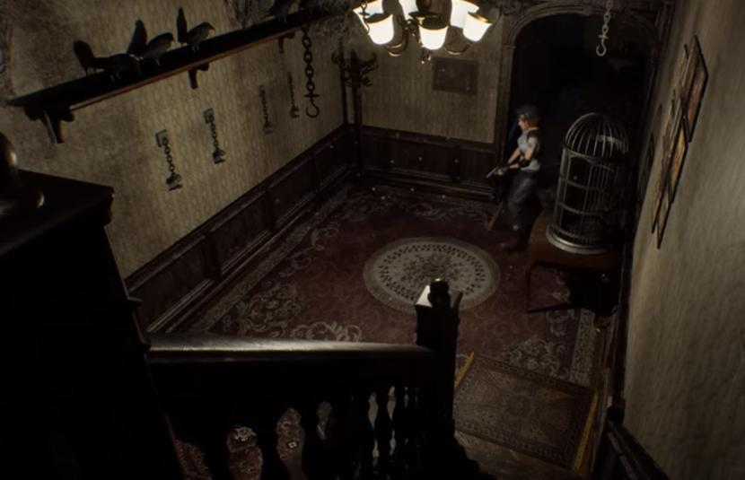

Figure 3. Resident Evil 1(1996)

1. Story

The story of this game will be mostly drawn from the well-known webtoon, ‘Sweet Home’[11]. The story follows a young adult stuck in his apartment building when the apocalypse breaks out in the city. He has to navigate to the top of his apartment building fighting off monsters and other enemies. As he progresses towards his goal, he will encounter other survivors; some may be an ally to him, while some will stand in the way of his goal.

A rough storyboard will be drawn of the games’ narrative to give a clearer representation of the storyline of the game. The issue of the story will correlate with the coding aspect of the game. Research must be done on how to create a cutscene in a game properly. Pop-up dialogues will also be considered to further enhance the story of this game, along with the possibility of some of the characters in the game having a voice actor to breathe life into the characters of the game. The story narrative will utilize the show don’t tell approach, where players will be rewarded with plot devices that will be related to the story if they explore every level of the game thoroughly. Minimal dialogue and cutscenes will be done to create a smooth gameplay experience for the player and to maintain the pace of the story. The story will be relying more on terror instead of horror. As written in a source [5], horror is depicted as external, perceptible, comprehensible, and measurable. The story narrative is driven by terror which is depicted as anticipatory dread as it relies on what is unseen which then the players will use imagination to fill in what is unknown.

1. Gameplay mechanics

The gameplay mechanics of this game will be inspired by a myriad of adventure games for the combat and exploring aspect of the game. For the horror elements, aspects such as jumpscare will be inspired from well-known horror games such as Outlast, Alien:Isolation, Phasmophobia and Little Nightmares. Research will have to be done on those games on how the jumpscare element is implemented. The fear intensity of a set piece in a game will also have to be researched more. According to a source[6], one of the fear intensity can be implemented with sound effects. For example, a loud sound can be played to trigger the fear of the player when the enemy starts to chase after the player. The player can also be given no weapons to fight against the enemy, which leaves the player with the only option; to run away and hide until the enemy is out of range.

The enemies in the game will have certain attack patterns that the player can learn and dodge. This in turn can allow the player to create a chain of combos to counter the enemies’ attack pattern. There will be balanced weapons and ammo system in the game. The player will have to conserve ammo and strategically dismember the enemies[8]. This will be an additional gameplay mechanic to the player as there are many ways to completing this game. Players can either take a more direct approach and destroy the enemies or a more stealthy approach, evading and avoiding the enemies.

**Professional and ethical considerations**

BSC code of conduct

1. Participants were not exposed to any risks greater than those encountered in their normal working life.

*This project will not induce any harm to any of the players that play the finished product. The game will induce mild discomfort, stress or anxiety, bright or flashing lights, loud or disorienting noises, smell, taste, vibration, or force feedback. The game will not impose any risk of harm that is greater than in ordinary life.*

2. The study materials were paper-based, or comprised software running on standard hardware.

*Participants are not exposed to any risks associated with the use of non-standard equipment. The participants will mostly be using standard PCs to experience the finished product of this project.*

3. All participants explicitly stated that they agreed to take part, and that their data could be used in the project.

*Participants are briefed on the genre of game they are experiencing. Participants will require consent on playing a survival horror game which will include jumpscares and moments of mild stress and anxiety. Covert observation, deception or withholding information are deemed to be high risk and require ethical approval through the relevant C-REC.*

5. No information about the evaluation or materials was intentionally withheld from the participants.

*This project will not withhold any information from participants or mislead them in any way.*

8. Neither I nor my supervisor are in a position of authority or influence over any of the participants.

*A position of authority or influence over any participant must not be allowed to pressurize participants to take part in, or remain in, any study.*

9. All participants were informed that they could withdraw at any time.

*The participant can choose to withdraw or stop playing the game if it is deemed too scary or if they are experiencing a level of stress and anxiety than predicted.*

10. All participants have been informed of my contact details, and the contact details of my supervisor.

*All participants have both me and my supervisor’s contact details. They will be given out at the start of the playtesting.*

11. The evaluation was described in detail with all of the participants at the beginning of the session, and participants were fully debriefed at the end of the session. All participants were given the opportunity to ask questions at both the beginning and end of the session.

*Participants will be briefed on the concept and genre of this game before they start playing the game. Participants will be debriefed and asked for criticism on the project.*

12. All the data collected from the participants is stored securely, and in an anonymous form.

*The data collected from this project will be stored securely and will not be misused or sld in any form. The data will only be used exclusively for this project and it will be stored once this project is completed.*

**Requirement analysis**

The main components of the game will be a player with general player movements such as walking, running, jumping and dodging. The player will be navigating through a series of levels to get to the top of the apartment. The player will be able to interact with NPCs(Non-playable character) such as engaging in a conversation with them. The player will be able to pick up weapons and attack the enemies throughout the game. The player will be able to carry multiple items such as an inventory system where the player can cycle through a number of weapons. From a level design aspect, the levels in the game will progressively be more difficult but to help balance the difficulty of the game there will be safe points in every level to avoid player from giving up too quickly. The player will be able to interact with certain aspects of the environment, one of which is picking up power ups or a form of currency for the player to upgrade or buy new items. There will be a possibility of adding multiplayer functionality if time allows it.

Within the gameplay aspect, a feature that is most likely to be implemented as a core element of the game is a feature where the player can detect nearby enemies through the static sounds from a cell phone. The player will be equipped with a cellphone at the start of the story. If there is an enemy the static noise will increase, alerting the player that there are enemy nearby. This feature is heavily drawn from the popular PlayStation Portable(PSP) game, Silent Hill: Origins.

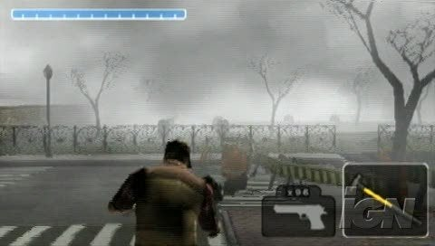

Figure 4. Silent Hill: Origins

This game will not require any high-end hardware to run. A basic laptop with a mid-tier graphic card will be able to run this game smoothly. The game will have controller support so the player will have an option to choose between keyboard and mouse or controller. The game will have a file size of 5-10gb. The player will not require a large storage to download and play this game.

The game will be teen rated. Any individual aged 13 and above will be able to play this game. Individuals under the recommended age will possibly experience a higher fear intensity, stress and anxiety. The game will not be too challenging, with puzzles that are easy to solve but still require a little thinking and intuition from players to solve. The game mechanics will be easy for the player to master and will not overwhelm the players. The player’s movement and interactions with the environment are kept to the minimum to prevent the players from being frustrated with the mechanics of the game. The experience will not be reduced for players with disabilities.

**Project planning**

Gantt chart

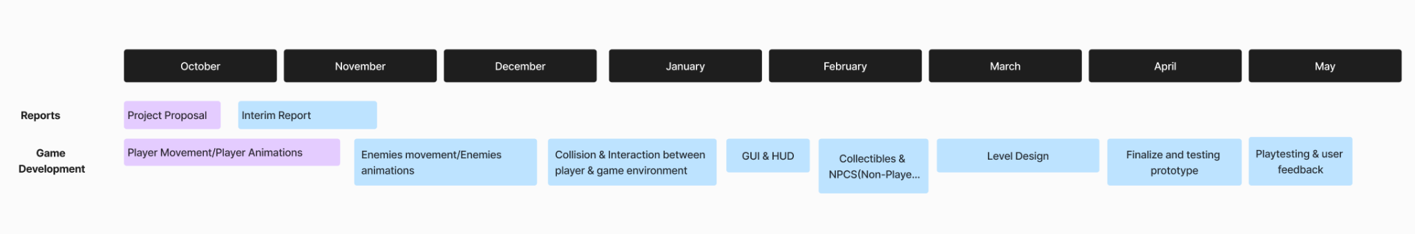

Current state

As seen from the images below, there is decent progress in the development of the project. Player movement has been implemented into the game. The player can move around and jump. Visually there is a Cinemachine attached to the player to allow the player to look around the player and it’s surrounding environment.

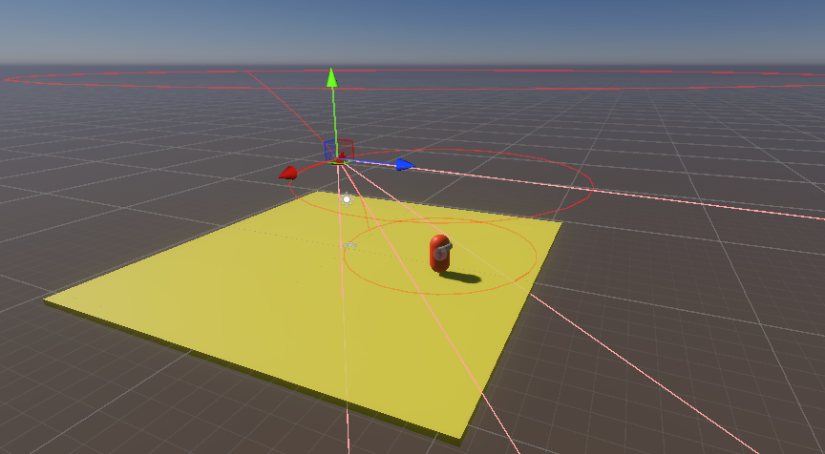

Figure 5 Cinemachine Freeloook attached to the player

Control Scheme is also implemented to provide options for the player to either use keyboard and mouse to move around or to use a controller to do so.

Figure 6 Control Scheme for the player

The current issue that is being worked on is allowing the player to dash, including a stamina system to balance the dash feature. There is steady progress being made on the project and I hope the progress continues to be steady until the completion of the project.

**References**

**Referenced games**

* Alien: Isolation
* Silent Hill: Origin
* Batman: Arkham Knight
* Resident Evil 1
* Fatal Frame

**Reference list**

1. Gibbons, R. (1992) *A Primer in Game Theory*. 1st edn. Pearson.
2. Glover, I. (2013) *Play as you learn: gamification as a technique for  motivating learners* [Preprint]. Available at: https://www.learntechlib.org/primary/p/112246/.
3. Koyama, Y. (2023) *History of the Japanese video game industry*. Springer.
4. Hicks, K. *et al.* (2019) ‘Juicy game design Understanding the impact of Visual Embellishments on Player Experience’, *Proceedings of the Annual Symposium on Computer-Human Interaction in Play* [Preprint]. doi:10.1145/3311350.3347171.
5. Perron, B. (2004) *Sign of a Threat: The Effects of Warning Systems in Survival Horror Games*.
6. Vachiratamporn, V. *et al.* (no date) *Towards the Design of Affective Survival Horror  Games: An Investigation on Player Affect*, *CSDL | IEEE Computer Society*. Available at: https://www.computer.org/csdl/proceedings-article/acii/2013/5048a576/12OmNxw5Bwq (Accessed: 18 November 2023).
7. Person, Matt and Barton (2019) *Vintage games 2.0: An insider look at the most influential games of a*, *Taylor & Francis*. Available at: https://www.taylorfrancis.com/books/mono/10.1201/9780429280542/vintage-games-2-0-matt-barton (Accessed: 18 November 2023).
8. Chad Habel & Ben Kooyman (2014) Agency mechanics: gameplay design in survival horror video games, Digital Creativity, 25:1, 1-14, DOI: 10.1080/14626268.2013.776971
9. Lim, T. *et al.* (no date) *Strategies for effective digital games development and implementation*. Available at: https://www.semanticscholar.org/paper/Strategies-for-Effective-Digital-Games-Development-Lim-Louchart/2c9b70521a0d3a5ee4c23983e8a8fde40aa65f7c (Accessed: 18 November 2023).
10. *Freeflow combat system in blueprints - UE marketplace* (no date) *Unreal Engine*. Available at: https://www.unrealengine.com/marketplace/en-US/product/freeflow-combat-system-01#:~:text=%22Freeflow%22%20combat%20means%20that%20the,and%20attack%20from%20every%20direction. (Accessed: 12 November 2023).
11. Kim, C.(2018). Sweet home. [online] webtoons.com.Available at: <https://www.webtoons.com/en/thriller/sweethome/list?title_no=1285>
12. Starloop, S.(2023). Starloop Studios. [online] starloopstudios.com. Available at: <https://starloopstudios.com/3d-vs-2d-the-eternal-battle-to-develop-video-games/#:~:text=3D%20games%20have%20become%20increasingly,they%20encounter%20in%203D%20games>.

**Appendices**

**Aim**

The aim of the project is to develop a horror adventure 3D game based on a well known Korean comic. This game will be made using the Unity game engine. The main reason this game is 3D is because players now want to immerse themselves into a realistic game environment with immersive storytelling with as much authenticity as possible (12).

**Primary Objective**

The purpose of this project is to experiment on what makes a scary game immersive for a player to have a sense of fear towards it. Horror games have been one of the few dominant genres of the gaming industry for the past decade. Some of the game mechanics in this game will be inspired from the likes of Outlast and Alien: Isolation. The game will consist of basic player character movements, including dodging and dashing.

**Extension Objective**

With this project, one of the objectives is to have an attempt at replicating the horror atmosphere that has been established from the original source[11]. The unique enemies established in the story with the immersive narrative which is fully fleshed out by the author himself is nothing to be taken lightly of. This game will teach me how to incorporate textures, lighting and many other techniques to enhance the horror gameplay for the players. The game will be developed as such that it will have a level of complexity with real time collision detection and save points.

**Relevance**

This project will improve my skills overall as a game developer. I will be able to experiment with new concepts that can be important in the development of my game. I will also learn how to manage and track the progress of my project. My ability code efficiently will also improve, along with my level design skills, sound effect skills, and storyboarding skills. I will also be able to experience seeking advice from my supervisor to provide guidance throughout the duration of this project.

Resource required

* Computer
* Software programs; Blender, Unity
* Keyboard and mouse

Bibliography

1. Starloop, S.(2023). Starloop Studios. [online] starloopstudios.com. Available at: <https://starloopstudios.com/3d-vs-2d-the-eternal-battle-to-develop-video-games/#:~:text=3D%20games%20have%20become%20increasingly,they%20encounter%20in%203D%20games>.
2. Kim, C.(2018). Sweet home. [online] webtoons.com.Available at: <https://www.webtoons.com/en/thriller/sweethome/list?title_no=1285>
3. Gibbons, R. (1992) *A Primer in Game Theory*. 1st edn. Pearson.
4. Glover, I. (2013) *Play as you learn: gamification as a technique for  motivating learners* [Preprint]. Available at: https://www.learntechlib.org/primary/p/112246/.
5. Koyama, Y. (2023) *History of the Japanese video game industry*. Springer.
6. Hicks, K. *et al.* (2019) ‘Juicy game design Understanding the impact of Visual Embellishments on Player Experience’, *Proceedings of the Annual Symposium on Computer-Human Interaction in Play* [Preprint]. doi:10.1145/3311350.3347171.
7. Perron, B. (2004) *Sign of a Threat: The Effects of Warning Systems in Survival Horror Games*.
8. Vachiratamporn, V. *et al.* (no date) *Towards the Design of Affective Survival Horror  Games: An Investigation on Player Affect*, *CSDL | IEEE Computer Society*. Available at: https://www.computer.org/csdl/proceedings-article/acii/2013/5048a576/12OmNxw5Bwq (Accessed: 8 November 2023).
9. Person, Matt and Barton (2019) *Vintage games 2.0: An insider look at the most influential games of a*, *Taylor & Francis*. Available at: https://www.taylorfrancis.com/books/mono/10.1201/9780429280542/vintage-games-2-0-matt-barton (Accessed: 18 November 2023).
10. Chad Habel & Ben Kooyman (2014) Agency mechanics: gameplay design in survival horror video games, Digital Creativity, 25:1, 1-14, DOI: 10.1080/14626268.2013.776971
11. Lim, T. *et al.* (no date) *Strategies for effective digital games development and implementation*. Available at: https://www.semanticscholar.org/paper/Strategies-for-Effective-Digital-Games-Development-Lim-Louchart/2c9b70521a0d3a5ee4c23983e8a8fde40aa65f7c (Accessed: 13 November 2023).
12. *Freeflow combat system in blueprints - UE marketplace* (no date) *Unreal Engine*. Available at: https://www.unrealengine.com/marketplace/en-US/product/freeflow-combat-system-01#:~:text=%22Freeflow%22%20combat%20means%20that%20the,and%20attack%20from%20every%20direction. (Accessed: 12 November 2023).

Study timetable



Interim log

18-10-2023 – Discussed the process of completing the interim report and the project proposal